Orecchiette with Creamy Carrot Miso Sauce
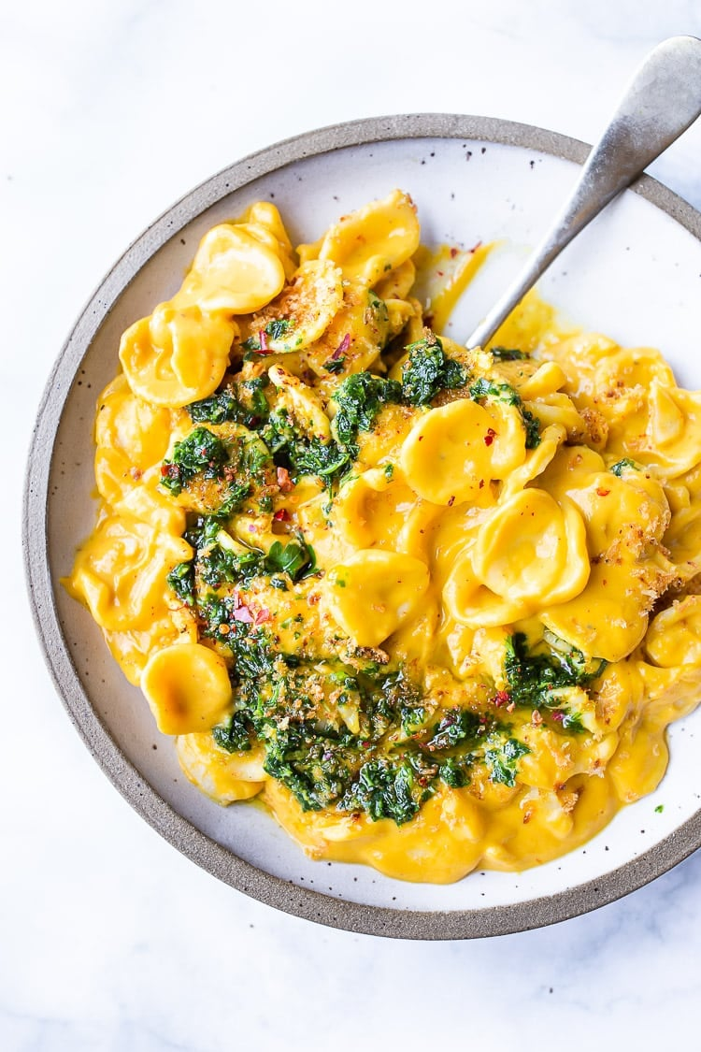
DESCRIPTTION:
simple delicious vegan recipe for Orecchiette with Creamy Carrot Miso Sauce, topped with a bright and tasty Carrot Top Gremolata (optional) and Toasted Bread Crumbs. Flavorful and healthy!
INGREDIENTS:
8–10 ounces orecchiette pasta, cooked in salted water, according to package directions.
2 shallots, rough chopped (or 1/2 an onion)
4–6 garlic cloves, rough chopped
2 tablespoons olive oil
2 heaping cups carrots, thinly sliced (3 medium carrots)
2 cups water
1/4 cup raw cashews (or sub raw hemp seeds)
1/4 teaspoon salt
1/4 teaspoon pepper 3 tablespoons White Miso Paste
1/2 cup carrot tops (tender leaves) packed or sub 1/2 cup more Italian Parsley
1/2 cup Italian parsley
1 fat garlic clove
1 tablespoon lemon zest ( zest from one med lemon)
1/4 teaspoon salt
1/3 cup– 1/2 cup olive oil (make sure it is not bitter-taste it!)
1–2 teaspoons lemon juice.

INSTRUCTIONS:
COOK PASTA: Set 6-8 cups salted water to boil for pasta, and cook according to directions.
COOK the SAUCE: Heat oil in a medium pot, over medium heat. Saute shallot and garlic until fragrant and golden, about 5 minutes, stirring often. Add carrots, cashews, water, salt and pepper and bring to a boil. Cover, lower heat to low and simmer gently until carrots are fork-tender, about 15 minutes. Stir in the 3 tablespoons of miso ( it doesn’t need to dissolve fully) and let cool for 5-10 minutes.
While the carrots simmer make the optional Carrot Top Gremolata and Toasted Panko or Bread Crumbs (see notes!)
BLEND THE CARROT MISO SAUCE: Once the carrots are tender and slightly cooled, place all in a high-speed blender, covering tightly with a kitchen towel, blend on the lowest setting, gradually increasing speed, until fully blended, creamy and silky smooth about 1- 1 1/2 minutes. Take your time here and get it SMOOTH!!!
Drain the pasta and pour the sauce over the pasta, gently warming if needed. Taste and adjust salt. (If you didn’t salt your pasta water, chances are you’ll need salt.)
Divide among bowls, and sprinkle with toasted bread crumbs and spoon the flavourful Carrot Top Gremolata over top.
NUTRITION:
Serving Size: without bread crumbs or Gremolata
Calories: 393
Sugar: 6.7 g
Sodium: 201.3 mg
Fat: 12.8 g
Saturated Fat: 2 g
Carbohydrates: 59.7 g
Fiber: 5.4 g
Protein: 11.5 g
Cholesterol: 0 mg

